***NAN-TECH***

***TECHNOLOGY EQUIPMENT STORE***

***International Burch University***

***MAN 309 - Entrepreneurship***

***Table of contents***

***Executive summary*** 3

***Company Description*** 3

***Product/Service Description*** 4

***Team (can be flexible with the position of this section)*** 5

***Market size – Define Niche based on research and using top-down logic*** 5

***Industry Analysis*** 5

***Customer Analysis-Value Proposition*** 6

***Competitior analysis*** 6

***Marketing plan*** 7

***Operation plan*** 7

***Financial plan*** 8

***Development plan (future goals, expansion)*** 9

***Critical risks*** 10

***Offering*** 10

***Appendices – none*** 10

***Poster*** 11

# ***Executive summary***

The NAN-TECH store is a company that sells computers, laptops and other things that belong to technology devices. The equipment is of high quality level. What sets us apart from other stores of this type is to work with the most well-known brands in the field of information technology. We have a wide range of devices designed for different users, from this reason every customer can find something for themselves in our store. The main goal of our company is to become a leading seller in this region. We believe that we have the knowledge and quality to reach this level and become the best in our business.

Some of the ways to achieve our goals are:

* Increase potential customer base from thousands to millions by broadening exposure local to national markets.
* Increase sales revenue, margins and profitability
* Break-even by on new venture by the end of Year 1,increase profitability in Year 2 and 3, and continue increasing company net worth each year.

# ***Company Description***

NAN-TECH, a domestic IT company, is focused on providing superior service to its customers. We give our clients full assurance that they will have a quality partner and the best technological solutions according to their needs. NAN-TECH is synonymous with advanced technology for people who want to be better. We are constantly in the process of developing and selling a large number of complex IT solutions, containing hardware, software and our service, for business users throughout BiH. We are focused on meeting the demands of the widest range of office business clients and advanced technology business users, especially educational institutions, public administration and public enterprises, media, industrial and tourism companies.

# ***Product/Service Description***

The target audience for our shop are all people who want to keep up with the latest technological devices, whether they are IT professionals or others. We offer a wide range of devices for various purposes, such as computers, laptops, cameras, various computer components, accessories for electronic devices and others. The purpose of our devices and their application is really wide. Whether you use them for business, study, research or fun, we guarantee efficiency in any application. The difference between us and our competitors is that we offer the best products with perfect efficiency for less cost, fast delivery and a large selection of well-known brands. Our goal is to satisfy the customer and become the best in our business in this market.

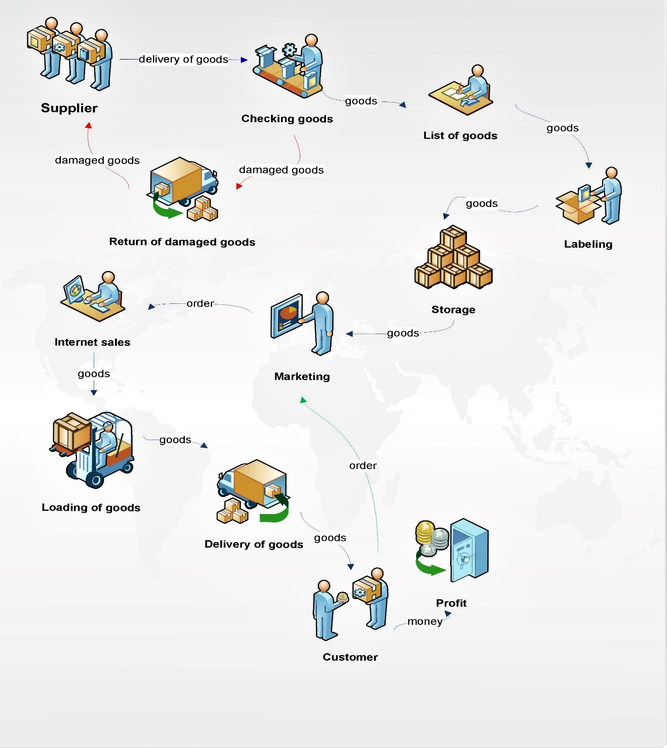

# ***Team (can be flexible with the position of this section)***

The NAN-TECH shop will operate virtually 24 hours a day 7 days a week. Due to our Internet operation the customer support will be a non-stop one. The team will consist of the following staff members, who have been developed to support these hours:

* CEO
* Marketing manager.
* Office administrator.
* Accountant.
* Two Customer Assistants.
* Stockers (full time and part time).
* Other

# ***Market size – Define Niche based on research and using top-down logic***

In the past years, most local IT shops had decreasing number of customers due to the success of large online worldwide famous shops that draw away local customers with help of their low prices. That is from where we got our idea. Our local market deserves one big web IT shop. We believe that with our low prices and variety of IT devices and equipment, customers would pick us as the place to buy rather than some other place online where they do not have free delivery and free access to our community.

We believe that our IT shop can provide a reasonable selection in the most important product areas, be competitive in pricing, and offer the customer a shopping environment that will assure repeat business.

We will focus on two significant customer groups: IT enthusiasts and IT specialists.

# ***Industry Analysis***

The IT retailing industry is highly competitive. Suppliers have a great deal of power in setting and negotiating the prices of their products and services. The costs of services and devices are generally not always that cheap, and buyers are willing to search for the most favorable combination of price and acceptable service. We are there to help them on that path.

# ***Customer Analysis-Value Proposition***

We said that our main customers are IT specialists and IT enthusiasts. It may sound a little bit too generic, but we are all aware that we live in the IT age, where every single person, from a little child to our grandparents, uses those devices and that they help them with their everyday activities.

# ***Competitior analysis***

|  |  |  |  |
| --- | --- | --- | --- |
|  | **Competitior 1** | **Competitior 2** | **Most important findings** |
| **Strengths** | -Offers shop online  -Delivers at home though whole the region within 24h | -The price of products is low  -Everyday there are new products | An online shop seems to be more and more important. Customers want to be able to order products from their home. Customers also like it when they got something for free or a discount on something when they buy products. |
| **Weakness** | -The price for products is higher than in other shops  -There is no way that a customer can see the products before they are ordred | -Ordering products takes quite some time  -The shop is not as much open as customers would like | Customers don’t like when orders don’t come on time |

# ***Marketing plan***

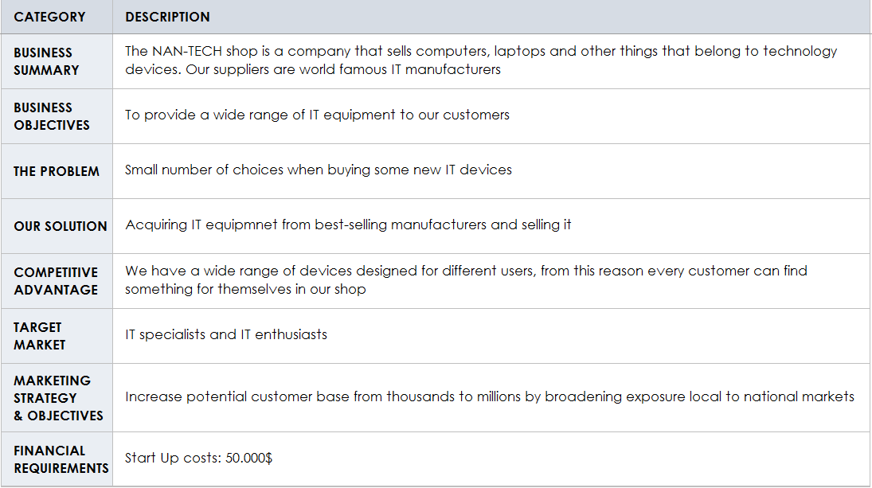

# ***Operation plan***

Our company will be based on selling IT equipment and devices for all IT specialists and enthusiasts. At the beginning, we will invest our own money. Eventually, we will make sponsorships with bigger investors and companies so we can make our offer of products wider. Our more detailed information about finances can be found in our financial plan. In the future, it is expected to have established connections and discounts with our suppliers via multiple contracts. With help of those discounts, we are making bigger profit. With our profit risinf, we will more fast pay out our loan.

# ***Financial plan***

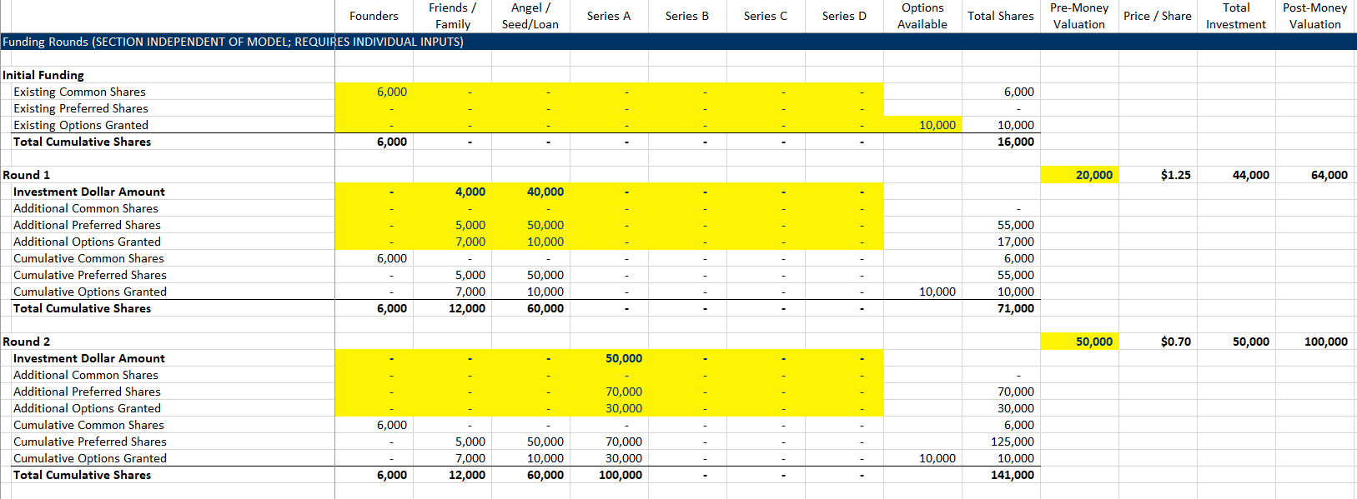

# ***Development plan (future goals, expansion)***

The plan for our IT shop, if it goes well, is to acquire the goods for sale from more manufacturers (get more warehouses), and hire more workers. A major goal is to become the best-selling IT shop in the country and get high-paying sponsors. Another goal is to have our own delivery service, so we can cut the expenses of the post company we are currently paying.

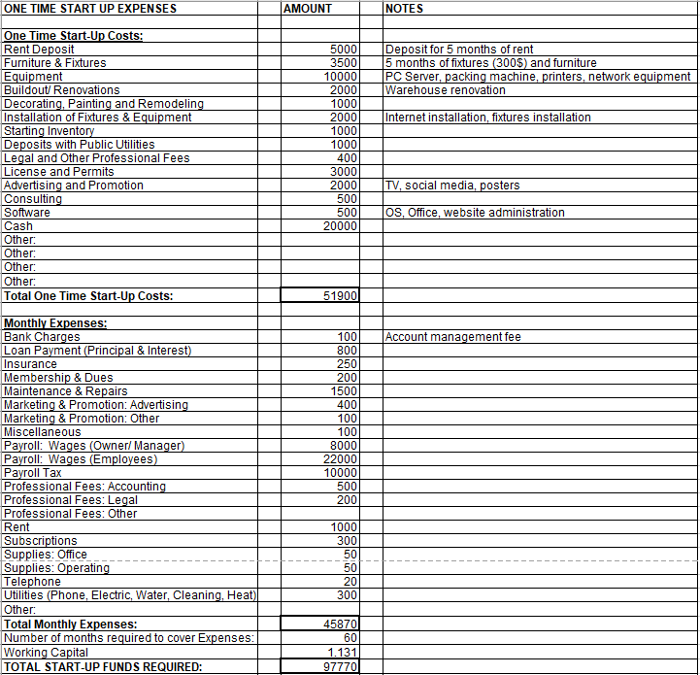

# ***Critical risks***

Low sales, rent prices, bad reviews, problems with delivery, faulty equipment, website problems, shipment problems.

# ***Offering***

50 000 KM for all costs (salaries, rent, bills, products, delivery)

# ***Appendices – none***

# ***Poster***

